**Create test performance vectors with the scores: 34, 57, 69, 92**

**(inclusive).**

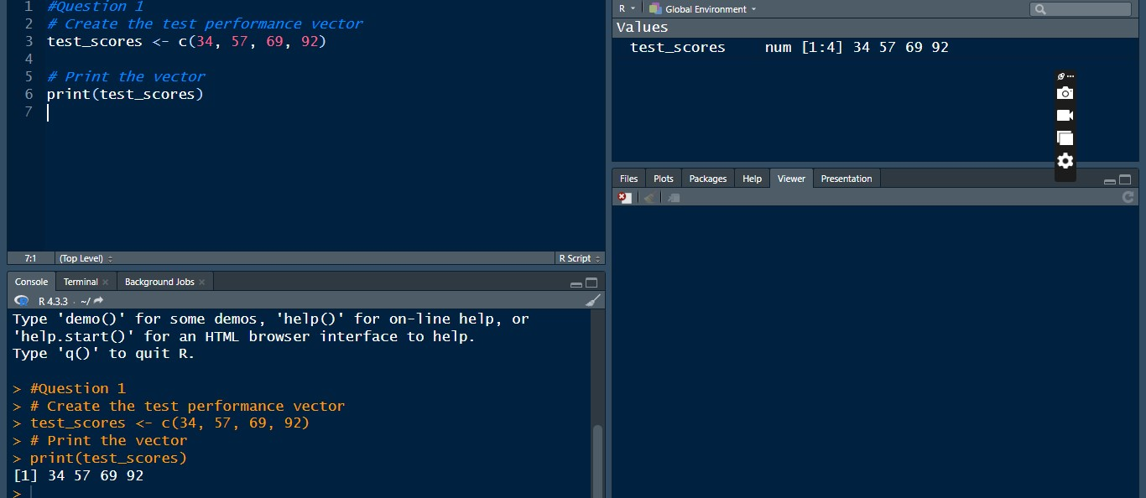

**Use R if statements to classify the performance as either "poor",**

**"average", "good", or "excellent".**

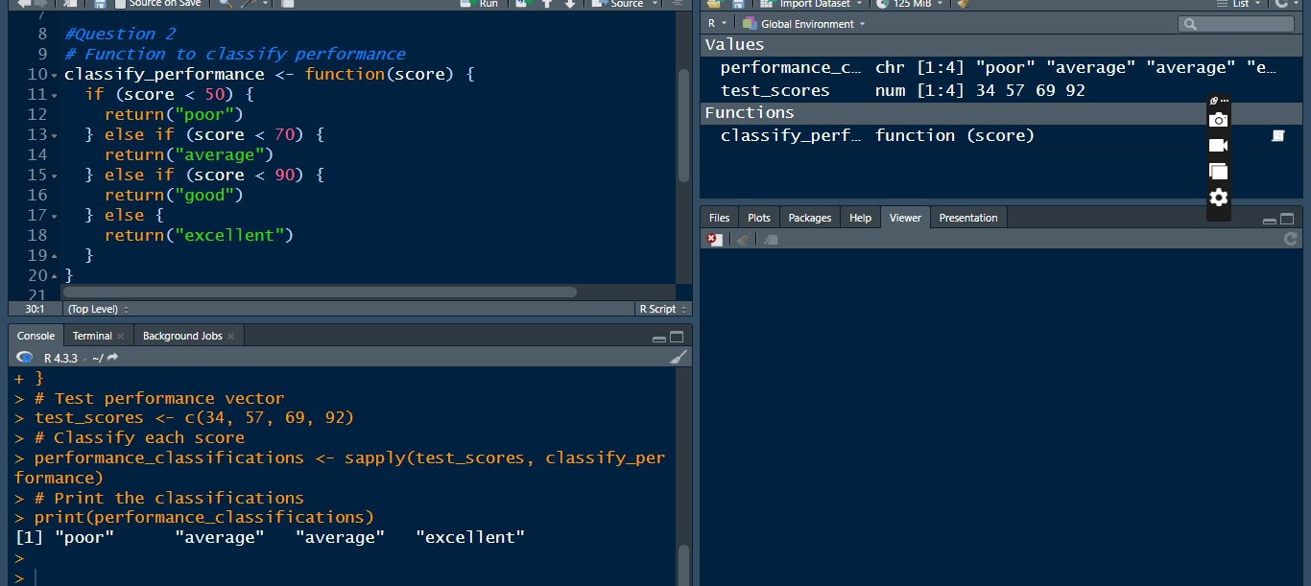

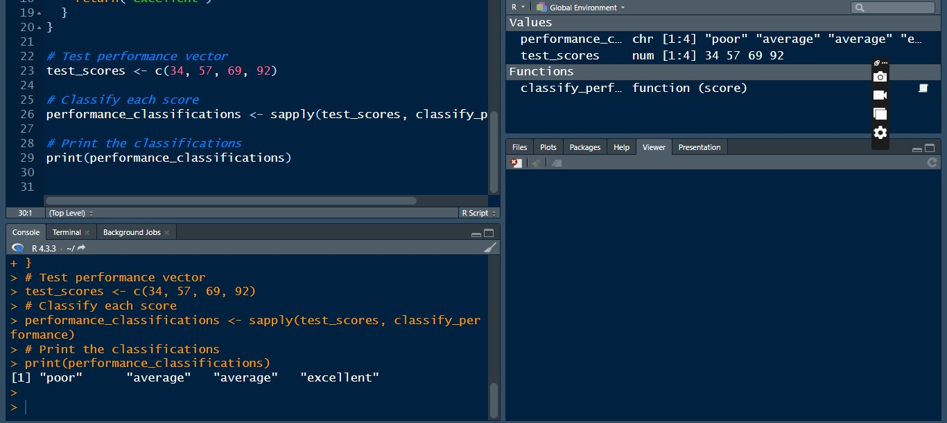

**Create a for loop statement in R to iterate through the scores and classify**

**each one.**

